Given the root of a binary **search** tree with distinct values, modify it so that every node has a new value equal to the sum of the values of the original tree that are greater than or equal to node.val.

As a reminder, a *binary search tree* is a tree that satisfies these constraints:

* The left subtree of a node contains only nodes with keys **less than** the node's key.
* The right subtree of a node contains only nodes with keys **greater than** the node's key.
* Both the left and right subtrees must also be binary search trees.

**Example 1:**

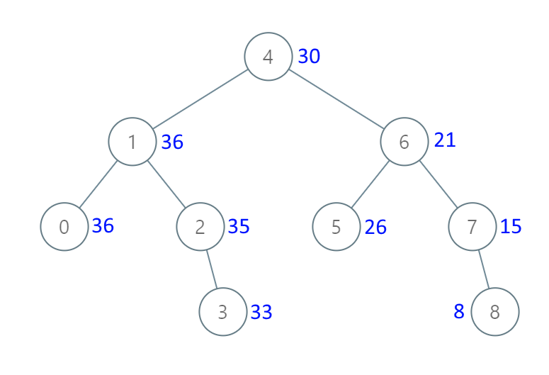

**Input:** [4,1,6,0,2,5,7,null,null,null,3,null,null,null,8]

**Output:** [30,36,21,36,35,26,15,null,null,null,33,null,null,null,8]

**Constraints:**

1. The number of nodes in the tree is between 1 and 100.
2. Each node will have value between 0 and 100.
3. The given tree is a binary search tree.

**Note:** This question is the same as 538: <https://leetcode.com/problems/convert-bst-to-greater-tree/>